Simple LED Blink using Esp32

Description:
The Simple LED Blink project using ESP32 is a basic embedded systems project used to understand digital output control with a Wi-Fi enabled microcontroller.
In this project, an LED is connected to an ESP32 board and programmed to turn ON and OFF at a fixed time interval.
This project helps beginners understand GPIO pin control, delay functions, and basic ESP32 programming using the Arduino IDE.

Block Diagram:
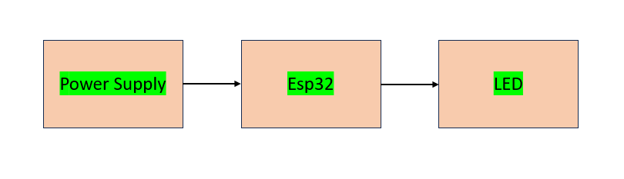

Pinout / Circuit Connection:
ESP32 GPIO 2 → LED (with 220Ω resistor)
LED Cathode → GND
Power supply: 5V (from USB) or 3.3V (ESP32 onboard)
Components Required:
ESP32 Development Board
1 x LED
1 x 220Ω Resistor
Jumper wires
Breadboard

Working Principle:
The ESP32 sends a HIGH signal (3.3V) to the GPIO pin, allowing current to flow and turn the LED ON.
When the signal is LOW (0V), the current stops and the LED turns OFF.
The ON and OFF timing is controlled using delay functions in the program.

Operation (Step-by-Step):
- Connect the LED to the ESP32 as per the circuit diagram.
- Connect the ESP32 to the computer using a USB cable.
- Select the ESP32 board and COM port in the Arduino IDE.
- Upload the LED blink program to the ESP32.
- Power ON the ESP32.
- The LED turns ON for a fixed duration.
- After the delay, the LED turns OFF automatically.
- This cycle repeats continuously.

Code:
#define LED_PIN 2

void setup() {
pinMode(LED_PIN, OUTPUT);
}

void loop() {
digitalWrite(LED_PIN, HIGH);
delay(1000);

digitalWrite(LED_PIN, LOW);
delay(1000);
}

Conclusion: (Predefined/self-written)
The Simple LED Blink project introduces the basics of Arduino programming and digital output control.
It is an essential beginner project that builds a foundation for more advanced embedded system applications.

For Your References:
[1] Espressif Systems, “ESP32 GPIO Control,” Espressif Documentation.
[2] Arduino, “Digital Write Function,” Arduino.cc.

